**DAILY ONLINE ACTIVITIES SUMMARY**

|  |  |  |  |  |  |  |  |  |
| --- | --- | --- | --- | --- | --- | --- | --- | --- |
| **Date:** | **19-06-2020** | | | | | **Name:** | **Kanaka BS** | |
| **Sem & Sec** | **6th & A** | | | | | **USN:** | **4al17cs039** | |
| **Online Test Summary** | | | | | | | | |
| **Subject** | |  | | | | | | |
| **Max. Marks** | |  | | **Score** | | |  | |
| **Certification Course Summary** | | | | | | | | |
| **Course** | Programming in C  Applications of python in DA and ML | | | | | | | |
| **Certificate Provider** | | | **Shilpa**  **Dr. Mohideen**  **Badusha** | | **Duration** | | | **4hours** |
| **Coding Challenges** | | | | | | | | |
| **Problem Statement:** 3 Programs | | | | | | | | |
| **Status: Solved** | | | | | | | | |
| **Uploaded the report in Github** | | | | | **yes** | | | |
| **If yes Repository name** | | | | | **Online Coding Repository**  <https://github.com/kanakabs/Daily-Status>  **Workshop on Application of python**  <https://github.com/kanakabs/Online-Workshop-Applications-of-Python-programming> | | | |
| **Uploaded the report in slack** | | | | | **yes** | | | |

**SNAPSHOTS**

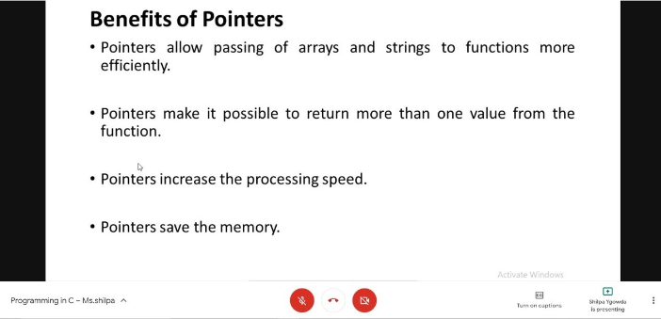

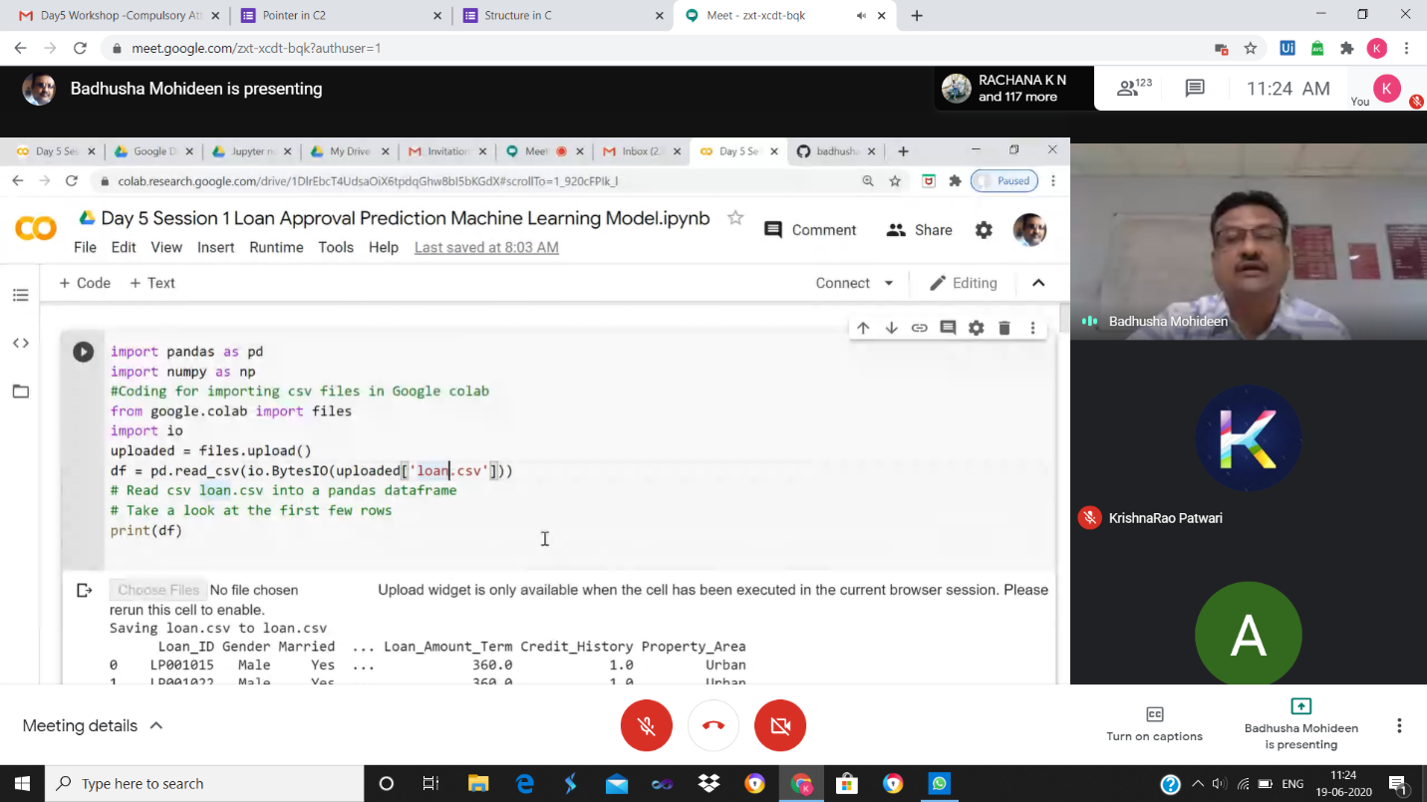

ONLINE CODING

**1. Write a Java program to create a doubly linked list of n nodes and display it in reverse order**

public class ReverseList {

class Node{

int data;

Node previous;

Node next;

public Node(int data) {

this.data = data;

}

}

Node head, tail = null;

public void addNode(int data) {

Node newNode = new Node(data);

if(head == null) {

head = tail = newNode;

head.previous = null;

tail.next = null;

}

else {

tail.next = newNode;

newNode.previous = tail;

tail = newNode;

tail.next = null;

}

}

public void reverse() {

Node current = head, temp = null;

while(current != null) {

temp = current.next;

current.next = current.previous;

current.previous = temp;

current = current.previous;

}

temp = head;

head = tail;

tail = temp;

}

public void display() {

Node current = head;

if(head == null) {

System.out.println("List is empty");

return;

}

while(current != null) {

System.out.print(current.data + " ");

current = current.next;

}

}

public static void main(String[] args) {

ReverseList dList = new ReverseList();

dList.addNode(1);

dList.addNode(2);

dList.addNode(3);

dList.addNode(4);

dList.addNode(5);

System.out.println("Original List: ");

dList.display();

dList.reverse();

System.out.println("\nReversed List: ");

dList.display();

}

}

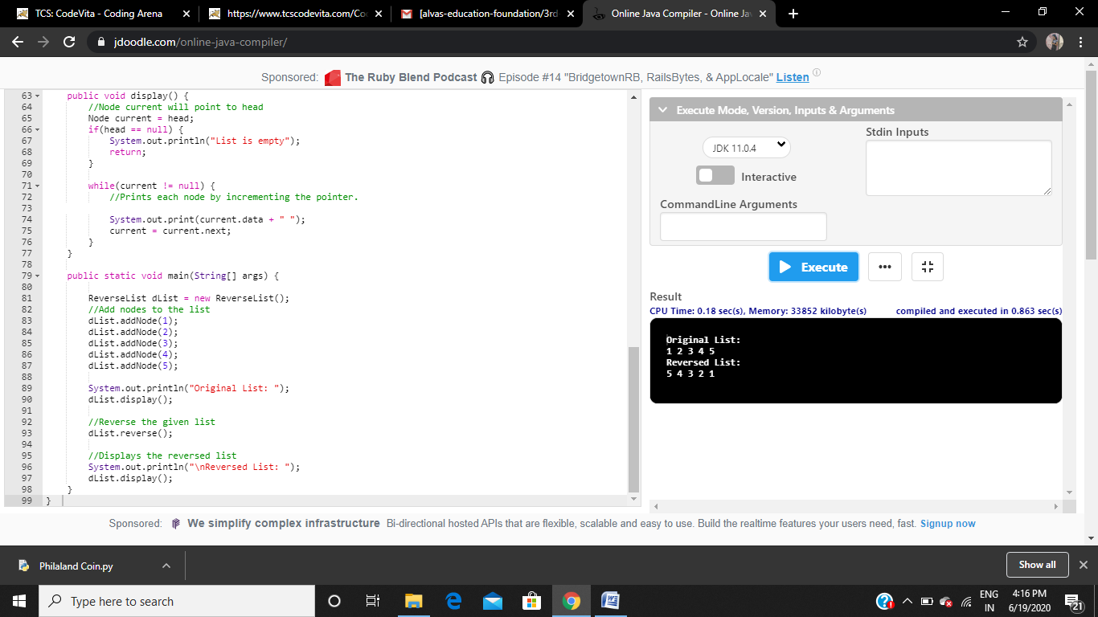

**2. Swapping 2 numbers using pointers**

#include <stdio.h>

void swap(int *x,int *y)

{

int t;

t = *x;

*x = *y;

*y = t;

}

int main()

{

int num1,num2;

printf("Enter value of num1: ");

scanf("%d",&num1);

printf("Enter value of num2: ");

scanf("%d",&num2);

printf("Before Swapping: num1 is: %d, num2 is: %d\n",num1,num2);

swap(&num1,&num2);

printf("After Swapping: num1 is: %d, num2 is: %d\n",num1,num2);

return 0;

}

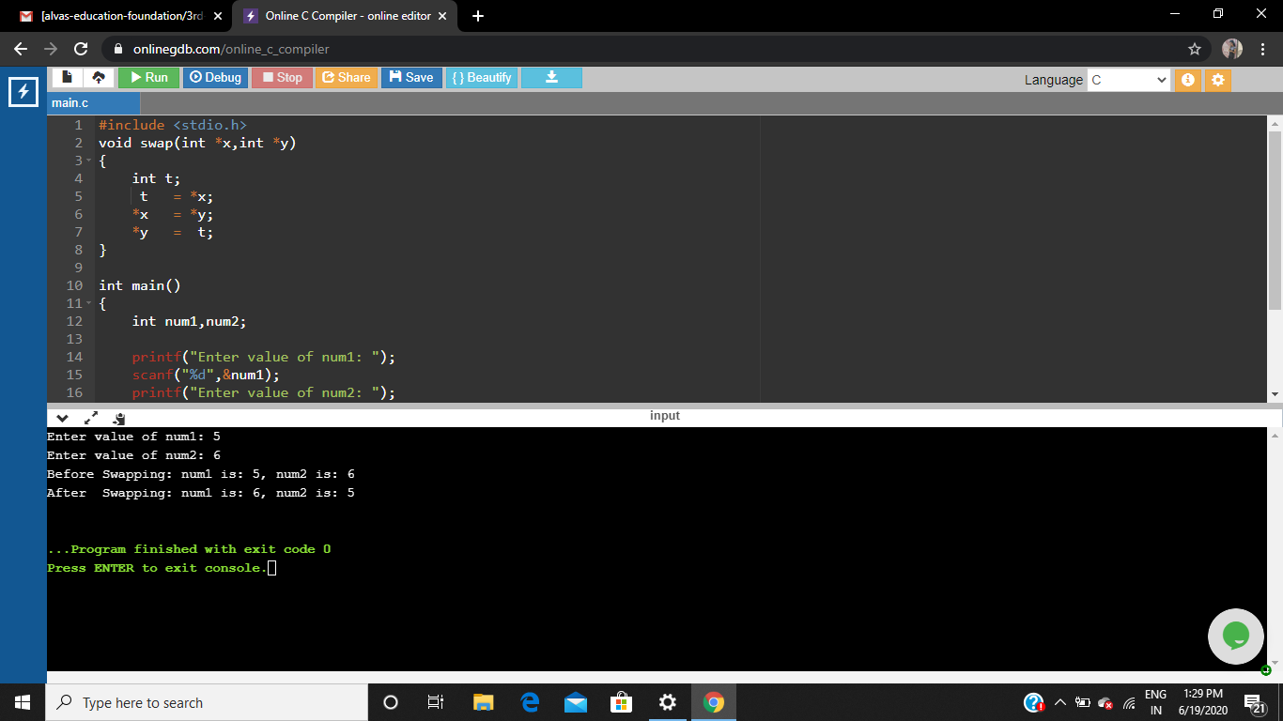

**3. Write a C Program to rotate a Matrix by 90 Degree in Clockwise or Anticlockwise Direction**

#include <stdio.h>

int main()

{

int c,l=1,n;

printf("Enter size of matrix (NxN): ");

scanf("%d",&n);

int arr[n][n];

printf("\nEnter matrix elements:\n");

for(int i=0;i<n;i++)

{

for(int j=0;j<n;j++)

{

scanf("%d",&arr[i][j]);

}

}

printf("\ngiven matrix elements:\n");

for(int i=0;i<n;i++)

{

for(int j=0;j<n;j++)

{

printf("%d ",arr[i][j]);

}

printf("\n");

}

while(l)

{

printf("MENU\n");

printf("1.clockwise\n");

printf("2.Anticlockwise\n");

printf("3.display\n");

printf("4.exit\n");

printf("enter choice\n");

scanf("%d",&c);

{

if(c==1){

for (int i=0;i<n/2;i++)

{

for (int j=i;j<n-i-1;j++)

{

int temp=arr[i][j];

arr[i][j]=arr[n-1-j][i];

arr[n-1-j][i]=arr[n-1-i][n-1-j];

arr[n-1-i][n-1-j]=arr[j][n-1-i];

arr[j][n-1-i]=temp;

}

}

}

else if(c==2){

for(int i=0;i<n/2;i++)

{

for(int j=i;j<n-i-1;j++)

{

int temp=arr[i][j];

arr[i][j]=arr[j][n-i-1];

arr[j][n-i-1]=arr[n-i-1][n-j-1];

arr[n-i-1][n-j-1]=arr[n-j-1][i];

arr[n-j-1][i]=temp;

}

}

}

else if(c==3)

{

printf("\nMatrix after rotating 90 degree:\n");

for(int i=0;i<n;i++)

{

for(int j=0;j<n;j++)

{

printf("%d ",arr[i][j]);

}

printf("\n");

}

}

else l=0;

}

}

}

